Name:Hong Khee Chee

ID:P21013167

System

Book Trading System for College Students.

Hand out date: 21-4-2021

Task 1 – User Story Mapping - 20 marks

Student A

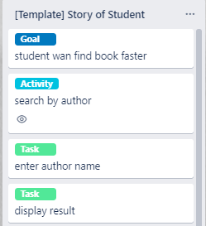

Student A want to find book faster in the book trading system

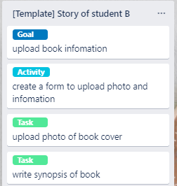

Student B want to upload book infomation

in the book trading system

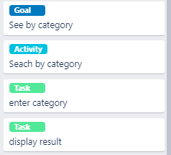

Student C want to search book by category

in the book trading system

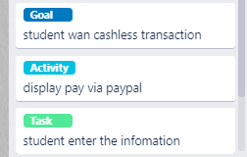

Student D want cashless transactions

in the book trading system

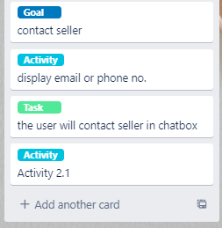

Student E want cashless transactions

in the book trading system

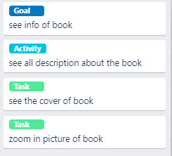

Student F want to see the infomation of the book

in the book trading system

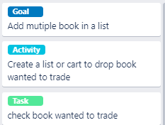

Student G want to add mutiple book in a list to see the book he want to trade

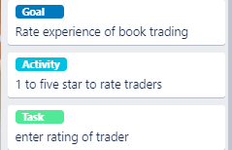

Student H want to be able to rate experience of book trading on a scale of 1 to 5



Student I want to write opinions on what liked/did not like



Student J want to view popular Book so that can better choose book to trade